An example of an ER Model and how a BA can tell if an ER Model serves the business purposes (business requirements) of a customer – Wholesale customer ACH Online Bill Pay?

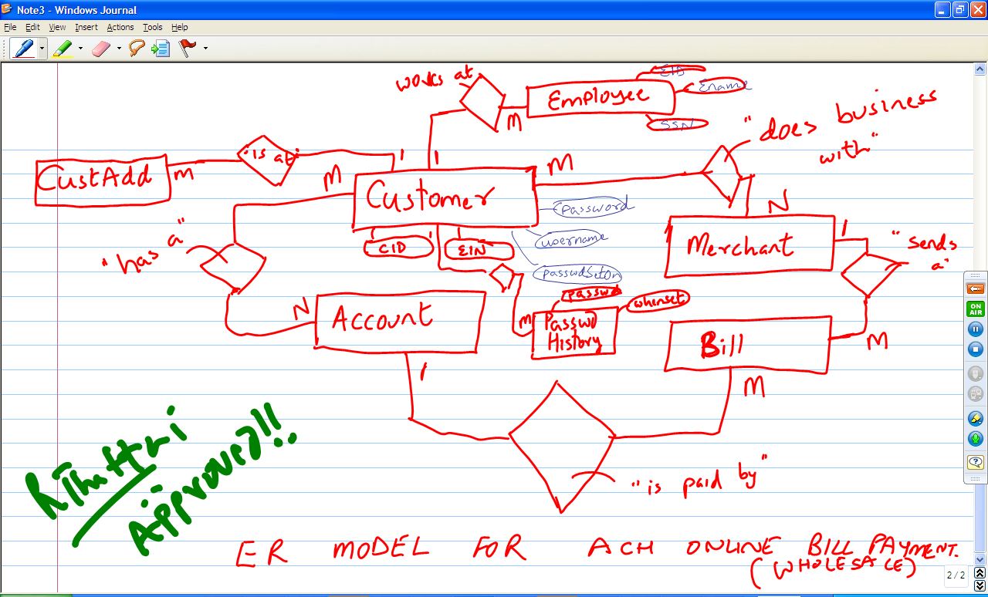

Security Enhancements Done: SCOPE
1. Age out passwords of clients every 6 months (Good discussion about whether this is too much vs. the security of the account).
2. 128 bit SSL encryption.
3. Passowrd strength is analyzed and suggested by the system if it is Strong,
Medium or Low.
- Database back-up security, all back-ups are encrypted for data protection.
- Not allow passwords to be reused until they are at least “10 times old”.

